**St Werburgh’s and St Columba’s Catholic Primary School**

**Religious Education Policy**

***Mission Statement***

*This is our school St. Werburgh’s and St. Columba’s*

*A place to be inspired, be accepted, be yourself and be unique*

*Be able to grow spiritually, academically and morally*

*Be able to contribute to the community and be a responsible global citizen*

*Be able to reach for the stars and fulfil your potential*

*A place, providing an excellent Catholic education for everyone*

*Where we belong, where everyone belongs.*

*‘.’*

**Action: Autumn 2024**

**Interim Review: Autumn 2025**

**Full Review: Autumn 2028**

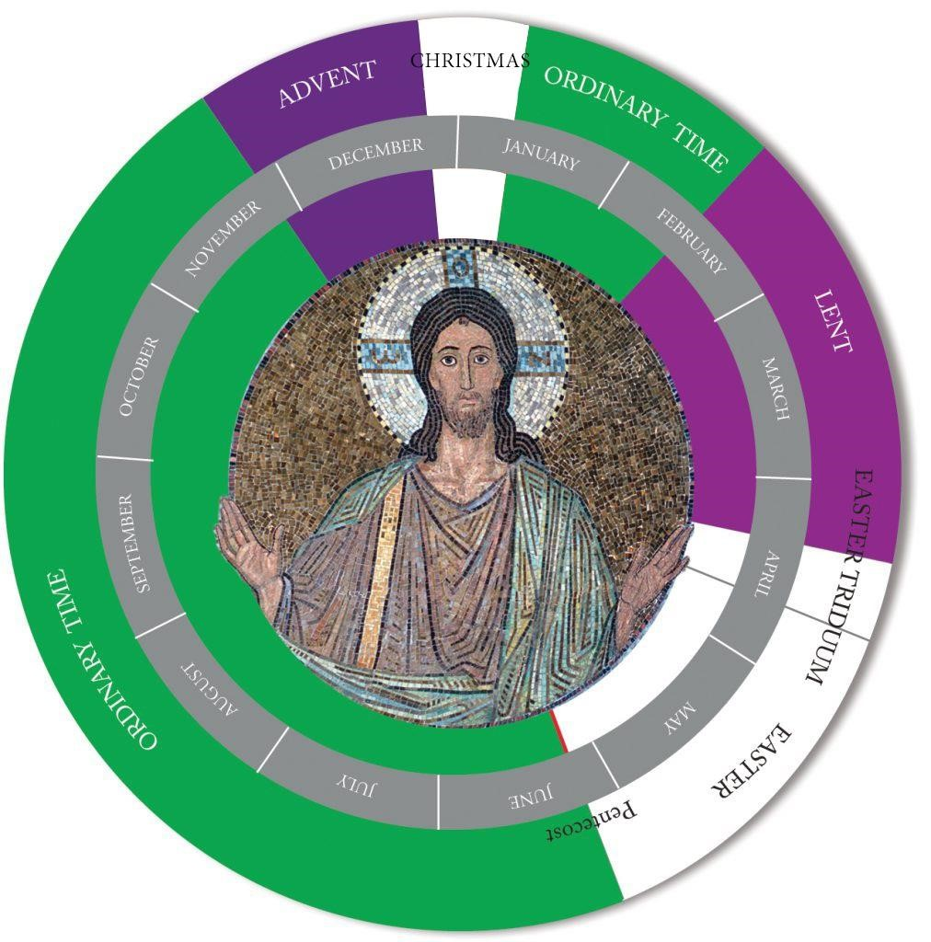

# Context

As a Catholic school, Religious Education is at the heart of our curriculum as we strive to proclaim and live the Christian values taught by Jesus Christ, within the Catholic tradition. This permeates every aspect of our school life. In partnership with parents/ carers and Parishes, we hope to lead children to a greater understanding of who God is and to celebrating with deeper faith and understanding, the liturgy of the Church.

At St Werburgh’s and St Columba’s Catholic Primary School, we are truly dedicated to serving our children and families with a rich, vibrant and inclusive Catholic education with Christ central to all aspects of our curriculum and God’s love shaping our actions and formation. We see ourselves as disciples, knowing and loving God through Christ’s teachings and example. As co-creators with God, we make Christ known by trying to be like Jesus.

Everyone at St Werburgh’s and St Columba’s Catholic Primary School tries to be like Jesus. We work together to make our school and community a welcoming and happy place to learn. As children of God, we care for each other, and we always try to do our best.

We want our children to know that they are loved by God and to love God, themselves and each other. Our wish is for children to deepen their faith to provide them with moral guidance and know they have Christ with them in a world where His protection and love is essential.

We believe that Prayer and Liturgy in a Catholic school names and celebrates God’s presence in our lives and we actively recognise and appreciate the spiritual and religious dimensions of life through feelings of awe, wonder, delight and joy.

Religious Education at St Werburgh’s and St Columba’s Catholic Primary School is a journey through the presentation, understanding and development of the Catholic faith, involving every member of the school community. We work with parents/carers as the first and foremost educators in a child’s life to develop and deepen our children’s faith journey. Religious Education and intrinsic promotion of the Catholic life of our school is rooted in our journey to deepen our relationship with our loving God.

Religious Education also contributes to the Catholic ethos of our school, and we ensure that we work together to build and maintain an authentic Catholic ethos reflected in all aspects of school life.

# Aims

Our subject specific aims for the teaching of Religious Education are to enable all children to:

The aims of Religious Education are:

1. to engage in a systematic study of the mystery of God, of the life and teaching of Jesus Christ, the teachings of the Church, the central beliefs that Catholics hold, the basis for them and the relationship between faith and life.
2. to enable pupils continually to deepen their religious and theological understanding and be able to communicate this effectively;
3. to present an authentic vision of the Church’s moral and social teaching to provide pupils with a sure guide for living and the tools to critically engage with contemporary culture and society.
4. to give pupils an understanding of the religions and worldviews present in the world today and the skills to engage in respectful and fruitful dialogue with those whose worldviews differ from their own.
5. to develop the critical faculties of pupils so to bring clarity to the relationship between faith and life, and between faith and culture;
6. to stimulate pupils’ imagination and provoke a desire for personal meaning as revealed in the truth of the Catholic faith;
7. to enable pupils to relate the knowledge gained through Religious Education to their understanding of other subjects in the curriculum.

# Content

Religious Education is an enriching subject, a subject at the heart of life, which all children should enjoy. As a Catholic school, we offer Religious Education as an important contribution to faith development of pupils.

The requirements of the Religious Education curriculum are currently met mainly through the use of two schemes. The Way, the Truth and the Life is used in EYFS and Years 5 and 6. We are introducing The Vine and the Branches in September 2024 to Years 1,2,3 and 4 which is a scheme derived from the new Religious Education Curriculum Directory. From September 2024, we are introducing the new curriculum as set out in the Religious Education Directory, ‘To see you more clearly’ in some classes.

During this transition period, we will continue to use existing schemes to ensure coverage. As a school, we use various schemes of work to enhance our curriculum provision for RE and to shape children’s moral understanding and responsibility to care for our common home. We use “The Way, The Truth and the Life” scheme of work and we use, CAFOD resources and study of Saints to deepen understanding.

Lessons are enriched by using a wide range of resources to stimulate, engage and challenge the pupils. These include relevant videos, music, posters, stories and use of the Bible.

The RED is broken down into six branches across the liturgical year. Each class works through the RED under the same branch, throughout the school year. The six branches are:

1. Creation & Covenant
2. Prophecy & Promise
3. Galilee to Jerusalem
4. Desert to Garden
5. To the End of the Earth
6. Dialogue & Encounter

Within each branch, the children will interact through knowledge lenses:

1. Hear
2. Believe
3. Celebrate
4. Live
5. Dialogue, this only applies to branch six.
6. Encounter, this only applies to branch six.

All Sacramental Preparation takes place in school, led by the school staff with support from catechists from the parishes. However, work undertaken and learned in Religious Education does help the children to grow in their knowledge and understanding of the sacraments of the Catholic Church. This supplements work carried out at home and in the parish in preparing children to receive the sacraments.

# Teaching and Learning

Religious Education in the Catholic school is a core subject and is given the careful planning and preparation time that is employed to other core subjects. It is allocated 10% of the teaching week (2 hours 35 minutes in Key Stage 1/ EYFS and 2 hours 35 minutes in Key Stage 2). This 10% should not be allocated in one block but should be split over as many days as possible so that children are constantly being brought back to the religious purpose of our school.

Teachers are encouraged to use a wide range of creative teaching strategies to deliver Religious Education so that children enjoy the subject and are engaged in their learning. The topics covered are those outlined in the RED, the curriculum ‘branches’, which closely follow the church’s liturgical year. These are enriched by using a range of visual and audio resources. Children are encouraged to participate in the lesson through paired work, group work, class discussion and drama. Where possible, links are made to other subject areas, particularly literacy.

# Staff Professional Development

We are committed to ensuring ongoing staff development in Religious Education so that all teaching staff grow in understanding of the Catholic faith. We have many training opportunities within our diocese for training. These are planned sessions throughout the school year.

The subject leaders attend Diocesan meetings and provides feedback and updates to staff through staff meetings. We liaise with the diocese to provide training days for ECTs and share twilights with other schools to explore scripture themes, planning and moderation.

The subject leaders and Head teacher provide relevant information for appropriate occasions in order to support the development of teacher knowledge and understanding, for example, information about the Church's liturgical year, information about the Sacraments to support individual teachers in their planning and teaching. Staff meetings, formal and informal, are integral to our monitoring process and we provide CPD for staff needs when they arise. The RE leads provide drop ins for staff to discuss teaching and learning in Religious Education.

# Planning

All teachers plan a half term’s work using the same planning grid. Plans follow the topics suggested in the RED and “The Way, the Truth and the Life” and “The Vine and the Branches “schemes which closely follow the liturgical year. Learning objectives, teaching activities and adapted pupil activities are carefully planned. Links are made to RSE learning objectives within each lesson.

We acknowledge the importance of using a wide range of teaching strategies and resources in the teaching of Religious Education in order to fully engage the pupils in their learning in this subject. These are reflected in teachers’ planning.

**Assessment**

Informal assessment takes place through feedback and marking. Bridging back and quizzing provide opportunities for recall of prior learning and assessment.

Assessment in Religious Education is based on levels of attainment which should be in line with levels of attainment in other curricular subjects:

Half-termly assessment is judged using pupils’ verbal responses and written work. The assessments are recorded on context sheets and learning outcomes are highlighted according to how a child has performed. This is for all year groups and schemes.

As we begin to adopt the content of the new RED curriculum, we will use expected outcomes outlined for each year group to assess pupils. For the year groups using The Vine and the Branches, each year group has end of year learning outcomes, used as a summative assessment showing what the children should have learnt within Religious Education. These come under Understand, Discern and Respond (Ways of Knowing). Teachers will complete summative assessment for each term. Each term the SLT and class teacher will analyse the different groups of children to monitor progress and attainment.

At the end of each academic year levels are recorded on Target Tracker and HSC Grids. The grids are passed up to the next year group in order to track progress. Pupils who are not making expected progress are highlighted to the next class teacher who can adapt appropriately for the needs of the pupil.

A staff moderation meeting takes place termly to monitor and evaluate the attainment in R.E. in relation to other curricular areas and pupil progress meetings termly identify levels of RE compared to other core subjects.

External moderation meetings also take place and children’s books are moderated alongside work from other schools in the diocese.

# Reporting to parents

Annual pupil reports focus on each child’s progress with regards to achievements in the topics undertaken and attitudes to Religious Education.

**Time allocation**

10% of curricular time is spent on Religious Education in each class.

# SEND

Children with SEND are supported as in any other subject. Activities in Religious Education are to be adapted to meet the needs of all pupils in the class. Refer to SEN policy for further information.

# Homework

At times during the year Prayer bags are sent home to develop quality prayer time with families. A child from each class takes a bag home to keep for five days. Thought for the week is sent home on the weekly bulletin to provide opportunities for families to spend some time together reflecting on the weekly Gospel. Dependent on the topic children may be set tasks at home to support their learning.

# Review and Development

Religious Education is subject to constant review in the light of Diocesan Guidelines and current teaching practice. This involves the whole staff to ensure that necessary changes are made, and development implemented.